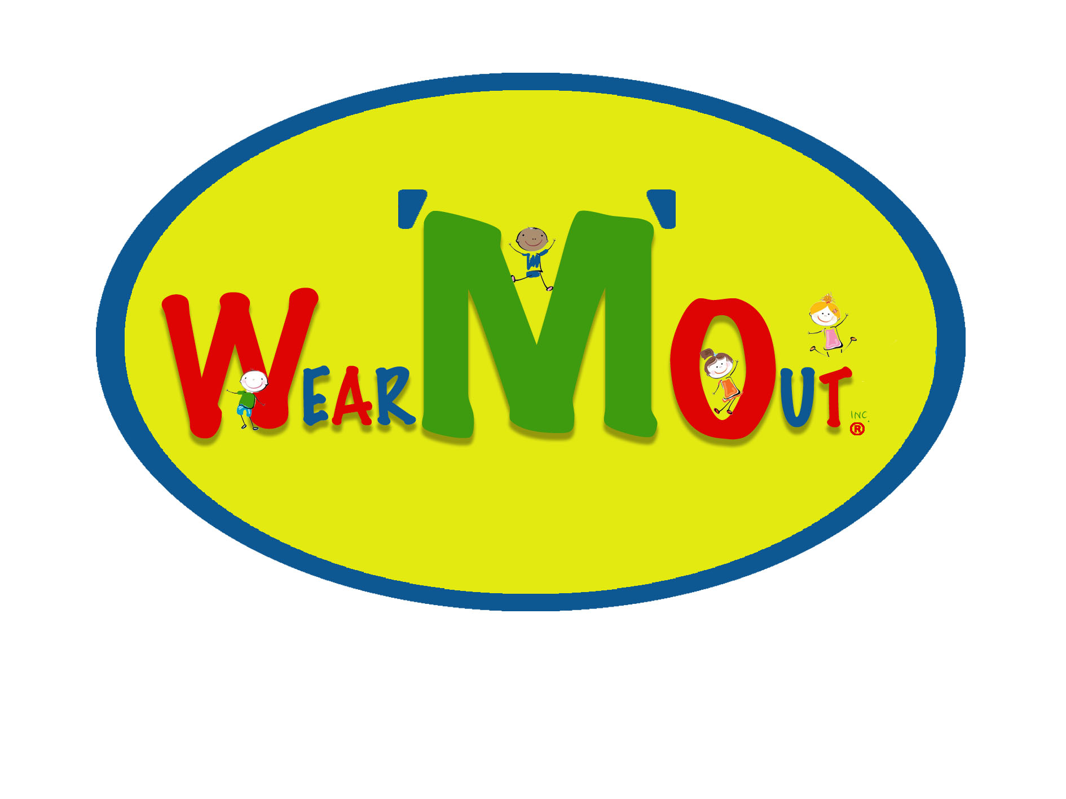
READ BEFORE SIGNING
WARRANTY AND CONSENT OF PARENT/GUARDIAN
ASSUMPTION OF RISK
RELEASE AND WAIVER OF LIABILITY
INDEMNITY AGREEMENT

IN CONSIDERATION of allowing MYSELF and my minor CHILD/WARD to participate in the program, related events and activities of the
WEAR ‘M’ OUT INC
I WARRANT TO YOU THAT:
1. I am a parent/guardian having full legal responsibility for decisions regarding myself and my minor child/ward, and
2. I am familiar with the risk of serious injury and death which any participant in this program must assume, and
3. I believe that myself and my minor child/ward is physically, emotionally and mentally able to participate in this program, and that his/her equipment is mechanically fit for his/ her use in this program, and
4. I understand, and will instruct my minor child/ward, that all applicable rules for participation must be followed and that at all times the sole responsibility for personal safety remains with myself and my minor child/ward, and
5. I will immediately remove myself and my minor child/ward from participation, and notify the nearest official, if at any time I sense or observe any unusual hazard or unsafe condition or if I feel that myself or minor child/ward has experienced any deterioration in his/her physical, emotional or mental fitness for continued participation in the program.
I UNDERSTAND AND AGREE, ON BEHALF OF MY MINOR CHILD/WARD, MYSELF, MY HEIRS, ASSIGNS, PERSONAL
REPRESENTATIVES AND NEXT OF KIN THAT MY EXECUTION OF THIS DOCUMENT CONSTITUTES:
1. An unqualified ASSUMPTION OF ALL RISKS associated with participation in this program by myself, and minor child/ward even if arising from negligence, or gross negligence, including any compounding or aggravation of injuries caused by negligent rescue operations or procedures, of the program organizer and any persons associated therewith or participating therein, and
2. a FULL AND FINAL RELEASE AND WAIVER OF LIABILITY of the program organizer and all persons and organizations associated with it and the program including, without limiting the generality of the foregoing, its officers, directors, officials, agents and/or employees, other participants, sponsors, advertisers, owners and/ or lessors of the premises used to conduct the program, sanctioning bodies, medical or rescue personnel (the RELEASEES), of and from with the respect to all injury, disability, death or loss or damage to person or property whether arising from the negligence, or negligent rescue of or by the foregoing or otherwise, and

Cont……
3. an UNDERSTANDING NOT TO SUE the RELEASEES for any loss, injury, costs or damages of any form or type, howsoever caused or arising, and whether directly or indirectly from the participation of myself and or minor child/ward in the program, and
4. an AGREEMENT TO INDEMNIFY, and to SAVE and HOLD HARMLESS the RELEASEES, and each of them, from any litigation expense, legal fees, liability, damage, award or cost, of any form or type whatsoever, they may incur due to any claim made against them or any one of them whether the claim is based on the negligence or the gross negligence of the RELEASEES or otherwise.

I HAVE READ THIS DOCUMENT THOROUGHLY.
I UNDERSTAND THAT THE RELEASEES ARE RELYING UPON MY WARRANTIES, ASSUMPTIONS, WAIVER AND RELEASE,
UNDERTAKINGS AND AGREEMENTS WHEN ACCEPTING MY OWN and/or my MINOR CHILD'S/WARD'S PARTICIPATION IN THIS PROGRAMME.
I UNDERSTAND THAT BY SIGNING THIS DOCUMENT I GIVE UP SUBSTANTIAL LEGAL RIGHTS I AND/ OR MY MINOR CHILD/WARD WOULD OTHERWISE HAVE.
I SIGN THIS DOCUMENT VOLUNTARILY AND WITHOUT INDUCEMENT.

_____________________________________________________ _____________________________________________
SIGNATURE OF PARENT/GUARDIAN printed name of parent/guardian

_____________________________________ PHONE # (________)-(________)-(____________)
DATE

NAMES OF CHILD/CHILDREN

_________________________________________________ Age ______________________

_________________________________________________ Age ______________________

_________________________________________________ Age_______________________

_________________________________________________ Age_______________________

PLEASE NOTE This WARRANTY AND CONSENT OF PARENT/GUARDIAN ASSUMPTION OF RISK
RELEASE AND WAIVER OF LIABILITY INDEMNITY AGREEMENT will be kept on file for two years, and then destroyed in accordance with Alberta Records and Information Management Criteria.

